

**[Enter Restaurant Name]**

**Server**

**Training Manual**

**[Edition or publication date here]**

***[Restaurant Slogan Here]***



THIS PAGE LEFT INTENTIONALLY BLANK

Table of Contents

Introduction

Server Functions & Responsibilities

* General Job Guidelines And Responsibilities
* Server Opening Procedures
* Server Closing Procedures

The Guest

* You Must Be Able To Serve Many Different Types Of Guests
* I Am Your Guest
* Service

Quality Control

* Things to look for before leaving the kitchen:

Table Introduction

* Ordering Procedures
* Cooking Times & Handling Timing Problems

Personal Appearance

* Uniform
* Dining Room Dress Code

Suggestive Selling

Specials & Features Of The Day

Coffee - Tea - Desserts

Wine Service

* VARIATIONS

Closing Out A Table

* Presenting the Check
* The Farewell
* Methods of Payment
* Handling Cash

Check-Out Procedures

* Over Rings Or Voids
* House Promo
* Manager Promo
* Employee Discount/Customer Discount
* Now You Are Ready To Check Out!!

Alcohol Awareness

* To serve or not to serve?

Sanitation

Safety

* Major cause of food borne illness
* Always wash your hands after you
* Dispose of waste properly
* Keep insects and animals out by
* Handle ice and tableware properly
* Avoid cross contamination from one food item to another
* Store foods and equipment properly
* When cleaning stationary equipment
* Preventing falls
* Preventing electric shock
* Lift Properly
* Moving a cart properly
* Preventing Cuts
* Preventing burns
* Preventing fires
* Safe chemical handling
* Reading the MSDS (Material Safety Data Sheets)

Conclusion

# Introduction

Congratulations on being selected to perform one of the most important, challenging and rewarding jobs at [Restaurant Name]! As a Server, you will set the stage and have a direct impact on each guest's experience. You will determine  whether each guest feels welcome, appreciated and well cared for.

We will provide you with the training you need to be successful. We take great pride in our quality food and friendly, responsive service. Our high standards can only be maintained through great people like you who share our values and desire to do the very best job possible for our guests every day.

As a server, it is essential that you maintain an energetic, friendly and caring attitude at all times. It is your responsibility to see that each guest is made to feel special and enjoys our fun atmosphere and great food and beverages.

The guidelines listed on the following pages have been established to help you in your effort to provide these qualities to our guests. Along with the hands-on training you will receive, this manual will provide answers to questions you may have regarding your tasks, responsibilities and operating procedures for [Restaurant Name].

Once again, welcome to the [Restaurant Name] Team!

# Server Functions & Responsibilities

Successful sales and service result from confidence, which can only be developed through knowledge. We will provide you with ample material to develop the necessary knowledge and confidence in relation to service techniques, the menu and the wine list. You, as a server for [Restaurant Name], must learn it.

## General Job Guidelines And Responsibilities

When taking an order, always look the customer directly in the eyes, and stand erect. Never lean or write on the table. Never crouch down on your knees.

Never handle a glass by the rim with your hand over the drinking surface.

Never handle silverware with your hand over the eating surface.

When handling plates or food, never let your hand touch the eating surface or the food.

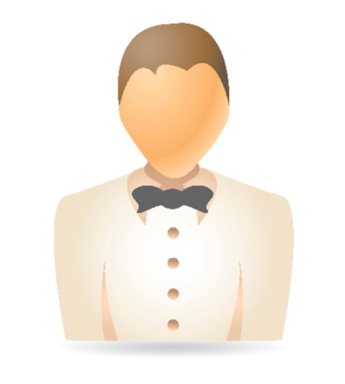Help your guests as much as possible. Get them cigarettes, be aware of the city's favored bars and dance places, know what movies are showing nearby.

Know your schedule.

Know what time to be here for each shift.

Know what the daily specials are and what they cost.

Know the history of the restaurant.

Know the managers.

Avoid any long conversations at any particular table. This will only upset your other customers.

Clear your mind of everything except work when you walk in the door. When you're at the table make sure your mind is at the table too. Guests can tell when their server is not totally mentally present with them at the table and it has a negative impact on the guests' experience and the server's tip.

If you get behind, ask for assistance. You'll never get in trouble for asking.

Keep yourself geared up so that you are ready for any rush. We get most of our complaints during the Restaurant's slow period.

Don't ever stand around or lean on anything. You can always be cleaning. Running clean-up, wiping shelves or the sales station, taking bus tubs to the back, etc. A server never goes into, or leaves, the kitchen empty handed. Full hands in, full hands out!

Always be sure that all your food is secure when you leave the kitchen. Never attempt to carry too much. Two safe trips are better than one catastrophe.

Always ENTER the kitchen keeping to the right. Always walk quickly, but never run. This will prevent serious accidents and extra work for everyone.

If an order is delayed in the kitchen, first inform the manager, and then tell your customers. The manager will go to the table and explain the situation as well. Get your stories straight. Never hide from your customers.

Learn to use your time wisely. When in your station, check all the tables before going back to the kitchen. Don't go to one table then go to the kitchen. Consolidate your trips. Fill up all glasses in your whole station, clear all plates, and then go on to something else. This is the secret to running volume and making more money.

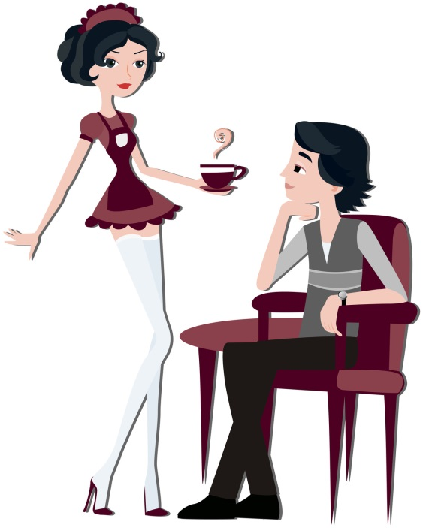Always try to take out complete orders. If the entire order is ready except for a side order, like a vegetable, take out the entrees and have someone follow you in a few seconds with the side order. Don't let the entrees get cold because of a side order. Everything goes out hot.

If your entire section clears at one time, don't take orders from four or five new hits at once. You'll end up running yourself to death for twenty minutes, and then have nothing to do for ten. Take one order, then go to the next table and tell them you will be right back to take THEIR order. Take drinks and appetizers out to the first table, and then go to the others. Never take three or four salads out at one time. This only means that you will have three or four orders of hot food coming out at the same time, which would be impossible to get out all at once. Think ahead.

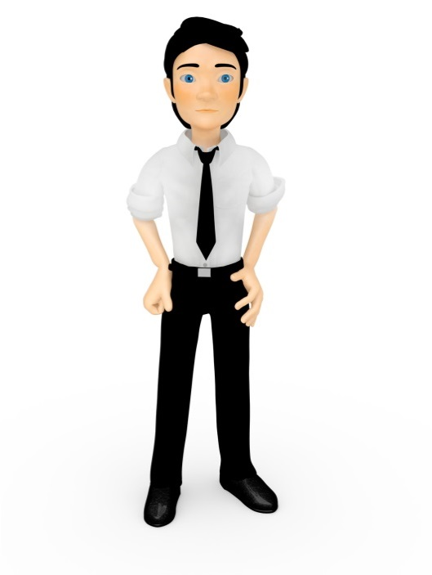You won't believe how patient people will be if they just see you. Don't hide from your customers. If you use this method in taking orders, you will find that your food will be out more consistently on time, and you will give much better service over all. You will have more time to converse with your customers. People look for more than just good service and food when they go out today. They want a total dining experience. They look for that little extra personal touch which only you as their server can give them. Never spend more than two minutes away form your station. No server ever made any money in the kitchen.

Anytime you wait on a customer, put yourself in their place and ask yourself if you would be happy with the job you did at that table.

If one person asks for something at a table, make sure you ask everyone at the table if they too would like that item. This will save you a lot of extra trips. If one person requests more tea, ask everyone at the table if they need more tea.

When serving coffee or hot tea, always turn the coffee cup so the handle is facing the customer. Place the cup on the right side. Ask people if they would like cream when they place their order for coffee instead of making an extra trip later.

When pouring tea or water, never handle the rim of the glass and always take the glass off the table and pour in the aisle.

Whenever you are reaching across someone or serving in front of someone, excuse yourself.

Always keep your fingers and thumb off the plates you serve.

Punctuality is very important. If you get to work late, you start out behind. BE ON TIME.

We know that servers work for tips. All people do not realize this. If you get slighted on a tip, it may be because people think the tip is included in the bill or because they just don't like to tip. The customer is NOT required to tip. If you get stiffed, it is unfortunate, but you must take the good with the bad. Any customer feedback about an employee regarding a bad tip will not be tolerated and is grounds for immediate dismissal.

NEVER SIT DOWN WITH A CUSTOMER or friend while on duty, even if they ask you to.

When waiting on parties of one, or an ace as they are called in the restaurant business, special attention should be paid to them. They are generally in and out quicker than other parties, and they are usually the best percentage tippers.

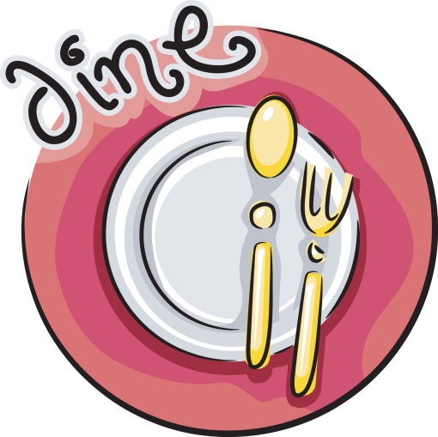If a customer leaves you an offer to buy you a drink, just tell them you will be happy to accept the offer another time, when you are not on duty.

The most neglected customer in the restaurant is the late customer. People who come in the last few minutes of the evening are usually the best tippers. They don't care how busy it was or how tired you are. They are here to enjoy themselves. Restaurants are noted for hurrying along late coming customers. We are not rushing them, but we must get their order because the kitchen is closing. They may sit there and enjoy their meal as long as they wish. Treat them as though they are the first customers of the evening.

A tip should never be removed from a table while the customer is still there. Unless, however, the customer hands it to you or motions for you to come and get it.

If you are having a problem with a door hostess or another employee, go directly to the manager. Do not harass the employee.

If you must go to the bathroom during the shift, ask someone if they will please watch your station while you are gone, and inform a manager so that they are not looking for you.

Unauthorized persons are not allowed in the kitchen. If one appears, politely but firmly escort them out and get the manager, or whomever it was they wanted to speak to.

No server is to change his or her station or pick up extra tables without the consent of the manager on duty.

Tips are not included: except for parties of 8 or more, and only with the manager's consent (15%).

Never serve a salad on hot plates.

Always check your glassware for cracks and dried food before filling them.

No eating or drinking in front of the house during operating hours. No gum chewing or smoking EVER.

Never attempt to adjust the lights or thermostats in the Restaurant. If there is a problem, get a manager.

A sales station can only be opened or closed by a manager. NO EXCEPTIONS.

Serve food from customer's left.

Serve beverage from customer's right.

Clear everything from customer's right.

Serve women and children first, then men.

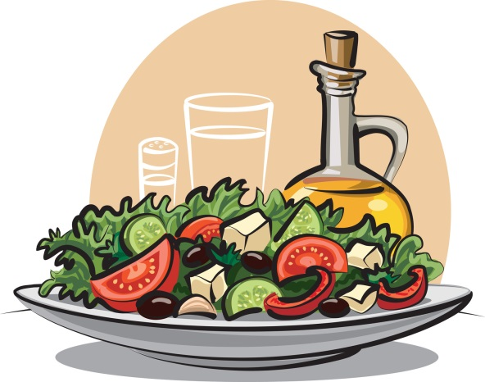Whenever you serve a course, ask if there is anything else you can do for the table.

Whenever serving a course, position the plate so that the "meat" of the course is closest to the customer.

Remove soiled china and silver after each course.

Top off with offer of additional beverages whenever anyone is getting low.

Bring condiments to the table before they are needed.

Offer fresh ground pepper with all salads.

Never walk away from a table without acknowledging its requests.

Never allow ashtrays to fill up. Cap them and change them often. One butt is enough, two butts are too many.

Never assume that the change is your tip!

## Server Opening Procedures

### At The Beginning Of Each Shift

1. Attend to all essentials (restroom, uniform adjustments, grooming) before work.
2. Clock in no sooner than 5 minutes before the start of your shift unless told otherwise from a manager.
3. Check your station assignments.
4. Check the Daily Service Board for specials, soup of the day, "86'd" items, etc.
5. Conduct your station check points

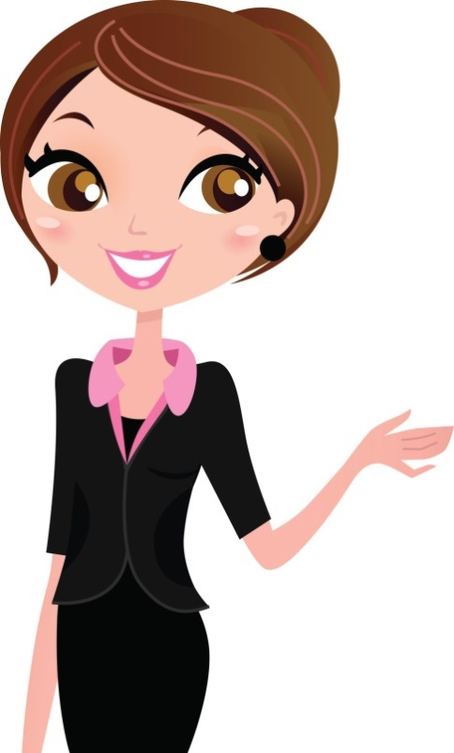Tables wiped

Clean window sills

Table base clean

Chairs wiped

Condiment containers clean and full

Salt and pepper shakers clean and full

Floor clean

1. Perform opening sidework - (wrapping silverware, making tea, cutting lemons)

## Server Closing Procedures

### At The End Of Each Shift

1. When station closes, perform the following –

Wipe tables

Clean chairs - seats, backs and legs

Wipe window sills

Clean table bases

Condiment containers clean and full

Sales & pepper shakers clean and full

Clean floor

1. Complete assigned closing side work duties
2. Begin check-out procedures
3. Clock out

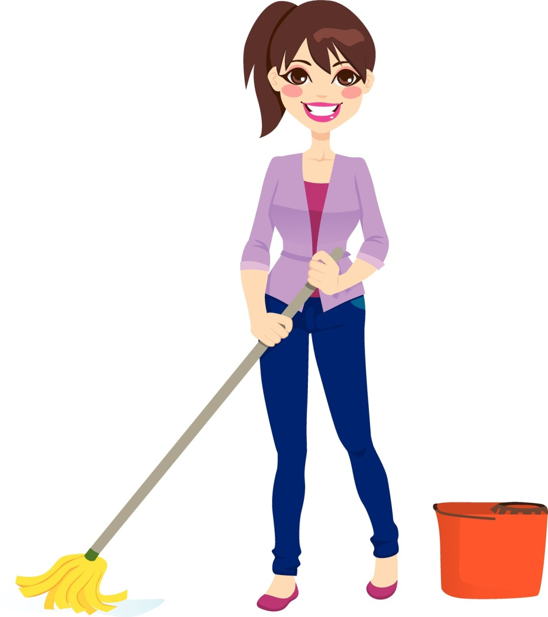

# The Guest

**C:\Users\Karens Laptop\AppData\Local\Microsoft\Windows\Temporary Internet Files\Content.IE5\Q73I4Y2H\MC900441830[1].wmfNever underestimate the importance of a guest!!!**

A guest is not dependent upon us -- we are dependent upon him (or her).

A guest is NEVER an interruption of our work - he is the purpose of it.

A guest does us a favor when he comes here -- we are not doing him a favor by serving him.

A guest is part of our business -- not an outsider.

A guest is not a cold statistic -- he is a flesh and blood human being with feelings and emotions, like our own.

A guest is a person who brings us his wants -- it is our job to fill those wants.

A guest is deserving of the most courteous and attentive treatment we can give him.

A guest is the lifeblood of **[Restaurant Name].**

## You Must Be Able To Serve Many Different Types Of Guests

To make appropriate selling suggestions, and give good service, it is helpful to recognize and know how to handle all types of guests. For example

|  |  |
| --- | --- |
| The Timid Guest: | Genuine interest and patient understanding will put this type of guest at ease. Even a comment on the weather can make him feel at home. |
| The Aggressive Guest: | This type must be handled in a courteous and businesslike manner. Kindness and politeness can often change him into a steady and appreciative customer. |
| The Fussy Guest: | This is one of the hardest guests to please. Try to stay one step ahead of him by learning the things that irritate him. Be sure to have everything just right, before serving the fussy guest. Remember all of the little things the fussy guest especially likes, even when they may seem peculiar to the average person. |
| *The Over-Familiar Guest:* | *Be courteous, dignified, and avoid long conversations. Stay away from the table, except when actual service is needed. Never try to give a wise crack answer to a smart remark. You will only cheapen yourself and lower yourself to the same level as the rudeness of the guest.* |
| The Guest Who Is Alone: | Don't call attention by asking if he is alone. Seat him where he can see what is going on. The guest may be lonely and want someone to talk to. Be friendly, but don't neglect other guests. With nobody to talk to, time seems long, so serve as quickly as possible. This could be your most critical guest. |
| *The Noisy Trouble-Maker:* | *Don't be drawn into arguments. Speak softly. Don't antagonize. Refuse to participate in criticism of management, the establishment, or other personnel.* |
| The Blind Guest: | Seat blind people with a dog so that the dog will not be noticed. Never hover over blind customers. Always stand near enough to help if needed. Issue menus in Braille to the blind guest. Always make a blind customer feel appreciated and important. |
| *Guest With Hand Or Arm Injuries/Disability:* | *Seat as quickly as possible. Be helpful, ask if you may assist them, but do not be too eager. Be considerate; do not call attention by hovering. Seat wheelchair guests at a table on ground level do not block an aisle. Always make a disabled guest feel important and accommodated.* |

## 

## I Am Your Guest

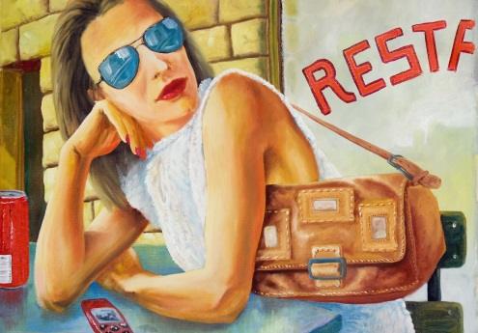*"You often accuse me of carrying a chip on my shoulder, but I suspect this is because you do not entirely understand me. Isn't it normal to expect satisfaction for one's money spent? Ignore my wants and I will no longer appear in your restaurant. Satisfy those wants and I will become increasingly loyal. Add a little extra personal attention and a friendly touch and I will become a walking advertisement for you."*

*"When I criticize your food and service to anyone who will listen, which I may do whenever I am displeased, take heed. I am not dreaming up displeasure. It lies in something I perceive you have failed to do to make my eating experience as enjoyable as I have anticipated. Eliminate that perception or you will lose my friends and me as well. I insist on the right to dine leisurely or eat in haste according to my mood."*

*"I refuse to be rushed as I abhor waiting. This is an important privilege that my money buys. If I am not spending big money this particular time, just remember, if you treat me right I will return with a larger appetite, more money and probably with my friends."*

*"I am much more sophisticated these days than I was just a few years ago. I've grown accustomed to better things and my needs are more complex. I'm perfectly willing to spend, but I insist on quality to match prices. I am above all, a human being. I am especially sensitive when I am spending money. I can't stand to be snubbed, ignored or looked down upon."*

*"Whatever my personal habits may be, you can be sure that I'm a real nut on cleanliness in restaurants. Where food is concerned I demand the strictest sanitation measures. I want my meals handled and served by the neatest of people and in sparkling clean dishes. If I see dirty fingernails, cracked dishes or soiled table clothes you won't see me again."*

*"You must prove to me again and again that I have made a wise choice in selecting your restaurant above others. You must convince me repeatedly that being a restaurant guest is a desirable thing in the first place. I can, after all, eat at home. So, you must provide something extra in food and service. Something so superior it will beckon me from my own table to yours. Do we understand each other?"*

## Service

**Definition of "service" according to Webster**: To work for. To minister to. To set on a table for a meal. To manage or work. To deliver or transmit.

**The Problem**: Webster never worked in a restaurant or took care of "our" guests.

|  |
| --- |
| [Restaurant Name]'s definition of service: |
| ***"The manner in which the customer is treated."*** |

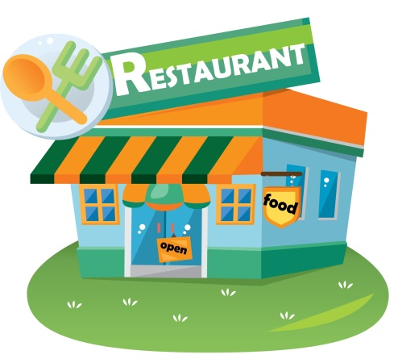If you think we are in the restaurant business, you are wrong! We are in the business of retail sales. We manufacture a variety of products and merchandise in our kitchen and bar. Then, we offer it for sale to customers in a display service area known as counter tops, tables, and dining rooms. Unlike most retail operations, such as department stores, our product has a limited shelf life, due to potential spoilage.

There is a greater sense of urgency for selling, moving, and serving our products. Our Restaurant is not merely a place to eat or drink, but rather a building designed to accommodate, facilitate, and promote the retail sales of food and beverage to customers through service. We provide service as a way of making sales to our guests.

|  |
| --- |
| To Serve Is To Sell |
| You don't buy coal; you buy heat |
| You don't buy glasses; you buy vision |
| You don't buy circus tickets; you buy thrills |
| You don't buy the paper; you buy the news |
| You don't buy circus tickets; you buy thrills |
| You don't buy the paper; you buy the news |
| You don't buy dinner; you buy sales and service. |

### The Difference Between A Restaurant And Other Retail Sales Organizations:

In a restaurant, we manufacture AND sell our product under the same roof.

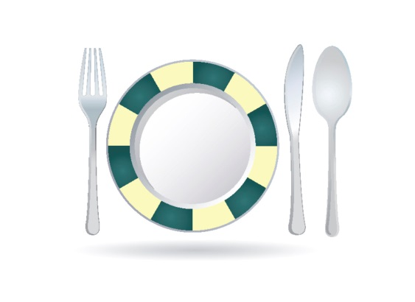In a restaurant, we know our guests are here to buy, not browse (no one comes in to try on the pasta).

In a restaurant, our guests may return as many as three times a day (lunch, happy hour, and dinner). Although this is unlikely, some guests may be regulars, day after day. No one buys the same shoes, pants, or socks three days in a row.

Department stores provide service. Restaurants provide hospitality: a warm feeling from feeding both the body and the soul.

More entertainers open restaurants and bars than department stores. Why? Because this is showbiz!

Our function as a ***Restaurant*** is to acquire and maintain business, to turn casual customers into loyal, repeat guests.

### Five Basics Of Service Excellence:

Look at me.

Smile at me.

Talk to me.

Listen to me.

Thank me.

### Remember, Every Restaurant Owes Its Existence To Its Customers.

When a customer forms an opinion of any food establishment, service and food presentation stand-alone. No matter how beautiful the surroundings or how delicious the food; poor service will certainly ruin the entire dining experience.

When developing good service, promote these qualities: promptness, courtesy, good manners, enthusiasm, and teamwork. In short, project a professional attitude. Unless you attain this goal, you will not be able to provide the high quality of service we expect here at [Restaurant Name].

Each time you service a table; our reputation rests in your hands. You have the power to influence the opinion of those people. If they are happy with you and your service, they will probably return. They may also recommend the restaurant to their friends. However, if they are not happy...

In order to be properly efficient, service people must be constantly aware of their customers' needs. Anticipate what they will want. Learn to read expressions and body language. If a customer is frantically rubber necking, waving his arms, or nodding, chances are he needs something. The more he must ask for service, the less enjoyable his evening will be. The tip he leaves you will reflect his feelings.

You will be trained, by our most experienced qualified people. The more attentive, enthusiastic, and patient you are, the sooner you will develop the work habits which make you an excellent server, capable of taking great care of our guests and be rewarded financially too.

Servicing the public, in any business, requires a vast amount of humility and patience. Always maintain a friendly, but professional attitude. If you need help, ASK FOR IT. Even if you become an excellent server, there will be times when you will get behind. Have enough consideration for your customers, and the house, to get assistance WHEN NECESSARY. Remember - Teamwork - no business can survive without it. We have provided you with a service manual. In it we have outlined some helpful suggestions to make your job here more profitable and enjoyable. These are the tools of your trade. Use them wisely and they will help you prosper.

Arrive on time for your shift properly dressed, with scrubbed hands and nails, pressed shirt, and clean shoes. If your appearance is sloppy, your performance will be sloppy. Your appearance, dress, posture, and expressions broadcast to everyone how you feel about YOU. Take pride in yourself, and others will be proud of you.

Introduce yourself. Customers want to know who is serving them: It is the added personal touch they enjoy. Also, if they have enjoyed their visit, they can request your station again. They might even tell their friends to ask for you. Call parties are the best tippers. In this manner, you can develop a following.

When people go out to eat, they want to relax. They want you to help them decide what to eat, when to order, what to drink, etc. You are there to fulfill their needs. Don't be pushy; do be confident. Often a customer is nervous. It is your job to make guests feel comfortable, so comfortable they want to come back.

Don't be afraid of customers. 90% of the people dining out won't notice a small mistake. Be relaxed, but alert, and efficient. Always be in control of a situation. Be strong, yet polite.

Always be yourself. Develop your own tableside manner. Avoid using repetitious phrases or seeming "plastic." Your customers will know you are faking it, and they will resent your attitude.

### Customer Service Turn Offs:

Dirty plates in hand when greeting customers, "Hi, ready for dessert?"

Not knowing what they are drinking, i.e., "I think this is the Diet Coke..."

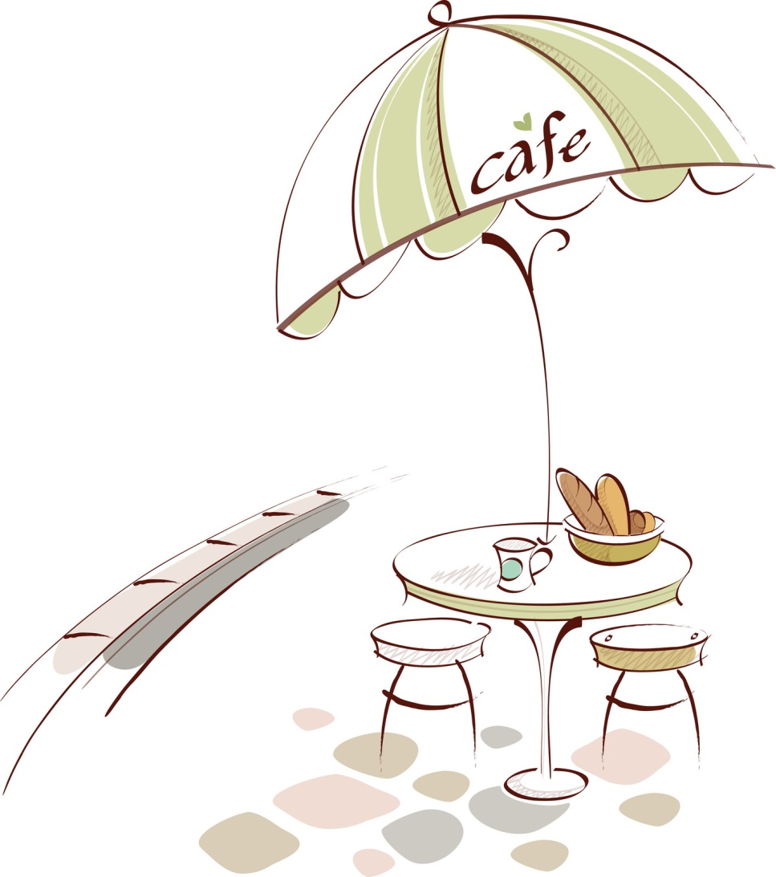"Discussion Groups" of three or four idle servers. All discussions should be held in employee break area, during approved break period.

Not acknowledging waiting guests.

Answering the phone with "Hold please."

Greeting guests with a number, i.e., "Two?” instead of a smile and "Welcome! Will anyone be joining you for lunch today?"

# Quality Control

Quality control is a primary responsibility of every employee serving food and drinks to the customer. You are the last person to come in contact with the food before the customer does. If something does not look right or is not presentable, DO NOT SERVE IT! The saying "People eat with their eyes" is very true. Make sure all of your products look good on the plates.

## Things to look for before leaving the kitchen:

1. **HOT food**. Few things are more basic but more important. Check to see of your food is hot. Just because something is in the window, does not mean that it is hot. If it is not hot, DO NOT TAKE IT OUT. Tell the manager. NEVER yell or argue with a cook. Go directly to the manager. This will alleviate a lot of problems.
2. **Clean plates**. Always check any plates, mugs, silverware, and napkins before you present them to the customer. Check food basket for grease spots, spilled food, etc.
3. 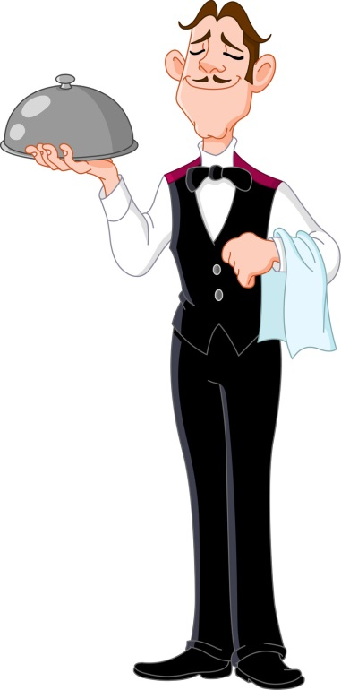**Correct portions**. Always check to see that the product is in the right portions. Make sure you are taking YOUR order. This can be very embarrassing at the table. Always ask yourself if you would eat that item if it were brought to you.
4. **Call for back-ups**. If something in the kitchen looks low and you are about to run out, TELL SOMEONE. If you take one of the last bowls of soup, call for back-ups. If the salad is warm or wilted, do everyone a favor, and say something before the customer is served.
5. **When bringing out drinks**, be certain the glass is clean, filled to the proper level, and that the garnish is correct, fresh and attractive.
6. **Cold food** **is as equally important as hot food**. Make sure cold foods are going out cold, not warm or cool, but cold.
7. **Bring necessary condiments with order**: i.e., ketchup, mustard, Parmesan cheese, etc.
8. **Check back** . . . within two bites to make sure everything is perfect. Don't say, "Is everything o.k.?" Guests here this trite saying so often it's meaningless. Say something like, "How's your filet cooked?" Be specific and sincere in wanting to know the answer.
9. 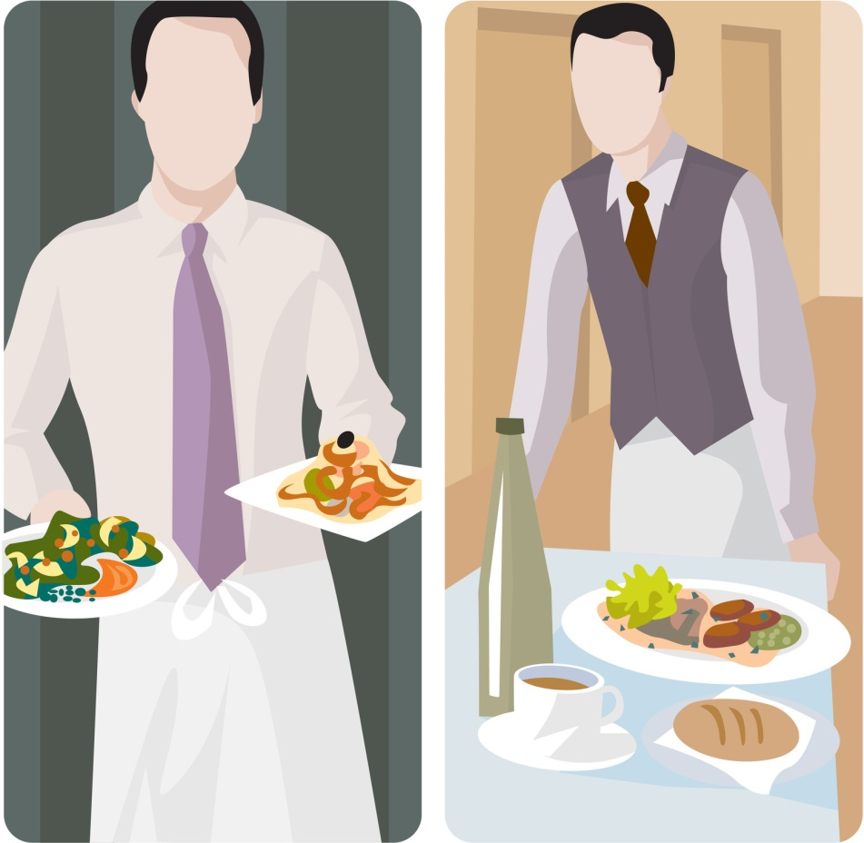**If the customer is not satisfied** . . . or there is obviously something wrong at the table, i.e., cracked glass, foreign object in food, not cooked properly, etc., use the following steps:

Apologize.

Remove the items immediately.

Get a manager. Management will take the necessary steps in making sure that the problem is corrected and that the customer is 100% satisfied.

1. Remember, the appearance of the exterior of the building, the greeting of the host, the cleanliness of the restrooms, the appearance of the staff, the quenching taste of our beverages, the flavor and freshness of our food, are all equal quality points. WE must control for the experience of our guests.

# Table Introduction

**CRITICALLY IMPORTANT!!** - Immediately acknowledge all new parties in your section. Regardless of how busy you are; you are never too busy to let your customers know you see them. They come here to be taken care of, so don't start out their dining experience by ignoring them. All new customers should be greeted within one minute.

If your hands are full, the customer knows automatically that you can't take their order, at that minute. You can pause, smile, and say "Hi, I'll be with you in just a minute." This will satisfy the customer so that they feel important and will be able to relax until you return.

When approaching a table your objective is to make you guests feel welcome and confident in knowing you're there to take care of them. You may develop your style and manner of accomplishing this but here are some suggestions to help you get started:

1. **Don't start out by giving your name**. Unless your guests already know you, they don't really care what your name is at this point. Focus on THEM. Make them feel welcome; that they've made a good decision to be at our restaurant and give them a sense they're in friendly, competent hands. Be observant, not scripted. It's o.k. to pay someone at the table a sincere compliment or try to open up some friendly rapport. Later in the meal it's good to give them your name by saying something like, "By the way, my name is Andrew, just let me know if you think of anything else you'd like."
2. **After delivering food to the table**, give the customer a few minutes to try the dish, and then return to the *table. "How is your steak cooked? Can I get you another...Scotch and water, ice tea?"* When checking on food items, always accentuate the positive, and eliminate the negative. Do ask, *"Did you like the way your steak was cooked?”* Don't ask, *"Was everything ok tonight?"* Ask an intelligent, specific question and show you're concerned about the answer you get. If something isn't right, do what you can make it right.
3. **Each time you take an order**, be aware of what might elevate the guests' experience. Be relaxed and friendly, polite and professional. Have an idea what extras (appetizers, sides, etc.) you are going to suggest based upon what you genuinely think will enhance your guest's dining experience. Allow the customers to finish ordering before you jump in with suggestions. If they hesitate, then it's your turn. *"May I suggest the (POPULAR MENU ITEM)? It's a one of our most popular dishes."* If they still hesitate, you might say something like, *"Would you like to have a little longer to decide? Take your time and let me know if I can answer any questions."*
4. **Know everything on the menu** in terms of what is in it, and what would go well with it. This will be covered in detail in your initial training and will be enforced often in our pre-shift meetings.
5. **Suggest premium liquor** in all cocktails. It makes the drink taste better, servers are tipped more, and when the guest drinks better, the server drinks better.
6. **Get your guests' first drinks** to them within five minutes from taking the order; no longer.
7. **Suggest specific appetizers** before you leave the table to get their first drinks. It saves you time and steps.
8. **Learn and use guests' names** when appropriate. Always use "Mr." or "Ms." unless you're told or you're absolutely sure it's proper to use a guest's first name.
9. **Make specific suggestions** at every step of the meal if you think it's appropriate: drinks, appetizers, sides, wine, desserts, after-dinner drinks. Always keep in mind, your first objective is to show your guests a marvelous time, not PUMP UP THE CHECK. Use your best judgment here. Sure we want to sell, but more importantly, we want our guests to leave delighted so they RETURN!

## Ordering Procedures

When approaching the table, be sure to have your pen ready, book open, and pad ready. Ask the customer if they have any questions concerning either the specials or entrees. After answering all the questions, if there are any, ask if you can take their order.

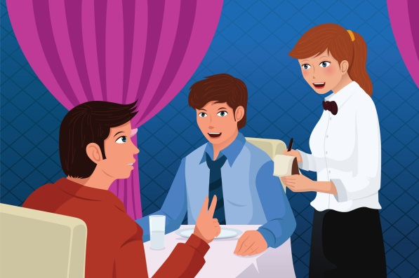Through either eye contact or verbal address, you may start to take their order. Be sure to gather all information from each guest before proceeding to the next. If possible, you should take the order from women and children first, and then the men.

Position numbers must identify customers; thus, the orders should be written and ordered in relation to position #1. Position #1 is the seat closest to the first person to your left. Moving in a clockwise direction, continue taking the orders. If no one is sitting in position #1, move in a clockwise direction until you find a customer. This customer will become the position #1 customer. The reason is that we need to know who gets what. We use a runner system so there's a good chance someone other than you will be delivering the food to the table. The runner must know where to place the food without asking.

Taking the order is the time for making recommendations. Suggest appetizers that will compliment the guests' meal. This is when wine can, and should, be offered.

Always get the cooking temperature for meats. Our cooking temperatures are as follows:

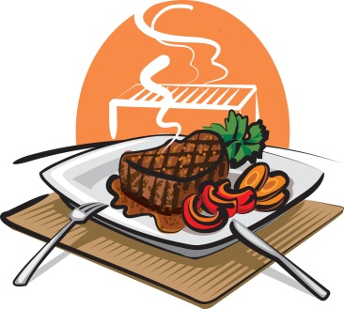Rare - Bloody cool center, touch of rawness

Medium Rare - Bloody red, no rawness of meat

Medium - Pink warm center

Medium Well to Well - Fully cooked with no redness

Use a small folder, clipboard, or other hard surface to hold your pad while you write up the order. It looks better and makes it easier for you. Begin taking the order at the same spot at each table. Start with the person closest to you on your left, and work around clockwise.

Example:

|  |  |  |
| --- | --- | --- |
| 2 |  | 3 |
| 1 | 4 |
|  | **YOU** |  |

Again, it is very important that every server records orders in the same way. If a food runner takes the food to the table for you, then he knows where each dish belongs.

In case of registers malfunctioning, follow these steps:

1. Write appetizers at top of ticket.
2. Write entrees under appetizers on the left, and how to cook them on the right of check.
3. For special orders like rare, be certain to make a notation on the ticket, to call special attention to the cooks.
4. Use the correct abbreviations. Menu abbreviations will be provided with your menu description sheets.
5. Write all side orders underneath entrees.
6. Write desserts underneath side orders.
7. At very bottom of ticket, put all teas, coffee, milk, and sodas.
8. Bar beverages will be listed on the back of the guest check only.
9. After all items have been totaled, circle the total. This way, there will be no mistake of where the total is. Also, write thank you, your name, and have a nice evening, enjoyed having you (etc.).

## Cooking Times & Handling Timing Problems

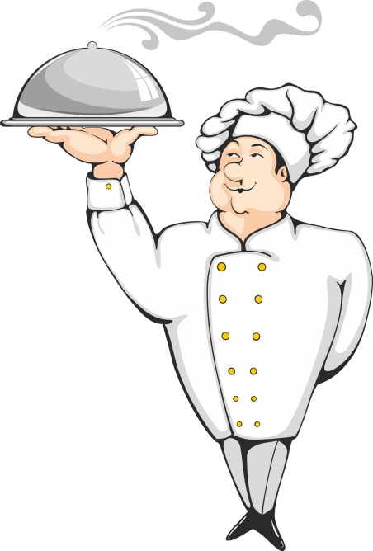With our firing system, once an order is rung to the kitchen, preparation of that item begins. It is imperative that appetizers are rung first. Once an order has been placed, you can expect to receive lunch items within six to twelve minutes, and dinner items within eight to twelve minutes. This time may lengthen during a busy rush. Your tables' experience is dependent upon your awareness and service to the customers from the time they are seated; to the time they receive their order. If, by chance, you have a long time ticket, do not hide from your table. Notify a manager immediately, and we will expedite the situation.

When a table has to wait longer than they should for their food, don't just apologize, offer them something for the inconvenience. It costs us hundreds of marketing dollars to attract new customers; we can't afford to lose any. A complimentary beverage or dessert is a small price to pay to let a guest know we care about their experience and we want them to come back and give us another chance to get it right.

In cases where the kitchen has been woefully out of sync, a dessert or beverage may not be sufficient. Tell the manager-on-duty about the situation. They have the authority to do whatever is needed to try to make amends for a bad-dining experience.

# Personal Appearance

Your overall image is our image. You make a distinct impression on each of our guests. The image you create can enhance or detract from our overall concept and the way our Restaurant is perceived in the minds of the guest. You are entrusted with handling our guests' needs and must, therefore, reflect cleanliness and wholesomeness at all times. Always remember . . .

You are responsible for keeping your uniform neat and clean at all times. There is no excuse for reporting to work out of uniform.

Do not wear scented lotion on your hands, as it clings to glassware.

A smile is part of your uniform.

At no time will employees chew gum or eat while in the public areas of our store.

Do not report to work with an un-pressed or dirty uniform, or un-kept hair.

## Uniform

When you walk through the front door of the Restaurant, "YOU ARE ON.” You will be informed of the uniform requirements when you start with us. Your designated uniform also includes a CONTAGIOUS, ENTHUSIASTIC ATTITUDE. You are required to enter the building for your shift in FULL UNIFORM. You are also required, when you leave the building, to be in FULL UNIFORM.

Your uniform also includes the following, without exception:

C:\Users\Karens Laptop\AppData\Local\Microsoft\Windows\Temporary Internet Files\Content.IE5\D5JUHB1P\MC900340186[1].wmfAt least two pens

Lighter

Wine Opener

Bank

Smile

## Dining Room Dress Code

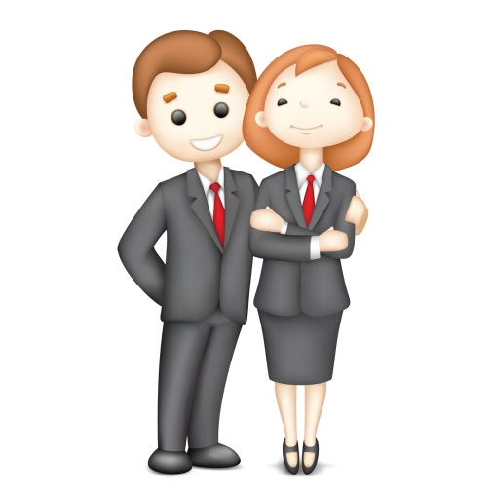Shoes - Black shoes only with non-slip soles that permit walking safely on wet or greasy floors. Shoes must be clean. Socks must be dark, preferably black.

Pants & Belts - Khaki pants only. Pants must be long enough to touch the top of the shoe. Solid color brown belts must be worn with pants that have belt loops.

Shirts - Oxford style, long sleeve navy blue or black dress shirts. Shirts must be in good condition, not soiled or stained. Shirts must fit at the sleeve.

Appearance - Clean and well groomed hair. Hair pulled back off the shoulder. Well-groomed hands, fingernails and fingernail polish. Facial hair should be neat and well-trimmed.

Accessories - No excessive cologne, perfume, make-up or jewelry. No earrings longer than 1 inch. No hat or unauthorized buttons can be worn.

# Suggestive Selling

People don't like to be "SOLD." Effective suggestive selling is subtle. You are doing the guest a favor, looking after his best interests by offering your knowledge and expertise and making honest recommendations.

Many of our guests are not familiar with our daily specials. As their intermediary, you are in the position to smooth the way for a confused guest. Above all, be sincere and honest. Always do what you truly believe is in the "guest's" best interest. Recommend items you know are superior and you are certain they will enjoy.

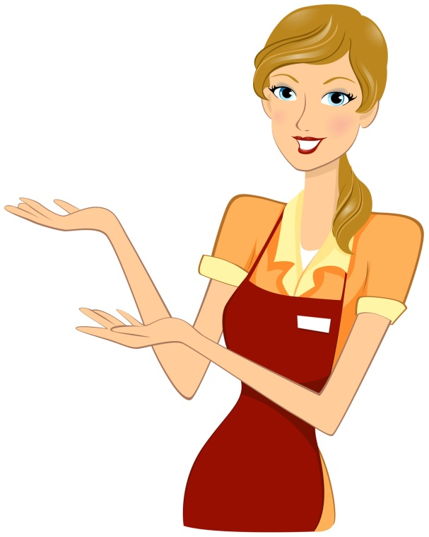NEVER OVER SELL! Always allow the guest to finish ordering before you start suggesting. Be aware of what the guest is ordering and make sure he understands what he is getting.

If a guest orders too much, and you are certain he can't handle that much food, advise him. He will appreciate your concern and honesty.

Suggest appetizers while people are studying the menu. "How about some Crawfish Cakes or sharing a spicy Cajun Shrimp Quesadilla," with your dinner this evening?"

Suggest side orders with entrees. "Would you care for seafood gumbo or a side salad with your Tabasco Filet?"

Always be persuasive and display complete confidence. Make suggestions so positively, that the guest wouldn't dream of questioning your recommendation.

Don't ask the guest a "yes or no" question. This requires him to make a decision. Remember, people come here to relax, not think. If you display confidence and complete product knowledge, the guest will trust your judgment and allow you to take care of him.

To sell effectively, you must sometimes bring a need or desire to try something to the surface. Make sure you use the right type of language.

For example:

|  |
| --- |
| "Would you like some wine tonight?" |
| If the guest responds, "No," your suggestion is over before it got started. |
| "Would you care for a bottle of wine with your dinner tonight? A bottle of Merlot would compliment your Filet and Grilled Salmon." |

With this approach, you have exhibited your knowledge and confidence of food and wine by suggesting a specific bottle of wine. The guest has now developed confidence in you. This will greatly enhance your opportunity to make this sale and make other recommendations.

Not every guest is going to buy a bottle of wine, appetizer, or dessert. But you must remember, we know two facts about every customer.

Every Customer:

Is planning to spend money.

Wants to have a good time and enjoy their meal.

If you keep these two facts in mind, you will be amazed at how easy it is to sell, providing, of course, you possess the necessary knowledge and confidence.

Through suggestive selling you can:

Increase check totals. The higher the check, the better your chances of a good gratuity.

Expose the customer to a new and different product he may not have tried, if you had not recommended it. Thus, the evening is more enjoyable and he may return with friends and has more reasons to tell others about [Restaurant Name].

Suggestive selling and making personal recommendations is another aspect of good service. Eventually, it will come easily as you build your self-confidence.

# Specials & Features Of The Day

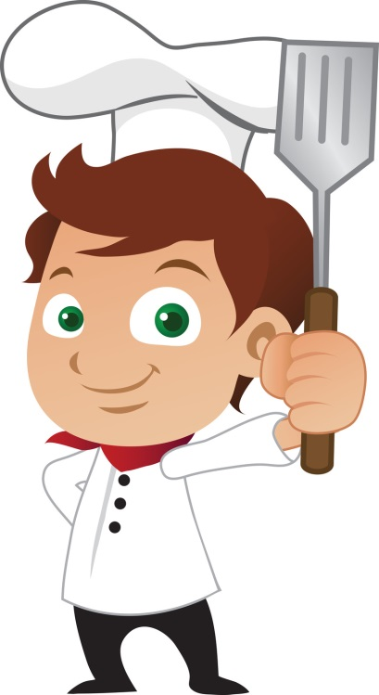Each day at pre-shift meetings, that day's Specials will be discussed at [Restaurant Name].

We offer daily specials for three reasons:

1. To add variety to our menu
2. To allow our customers the best of seasonal items.
3. To allow us to test items for future menu development.

These specials may include a drink special, an appetizer, a salad, a pizza, an entree, or a dessert item.

In addition to placing a "special" card on the table, you as the server will present the "specials" verbally. This enables you to describe them thoroughly, and answer any questions the customer may have.

When presenting the specials, you should start with drink specials, then appetizers, soups, and entrees. In describing the specials, you must use adjectives, which will entice the customers.

|  |
| --- |
| Bad Example |
| "Tonight we have New York strip with Vegetable Medley." |

|  |
| --- |
| Good Example |
| "Featured this evening is the tender New York Strip, wood-fired and served with fresh sautéed vegetables. The blend of hickory and oak add to the flavor of the juicy steak, complimented by the crisp combination of broccoli, cauliflower, carrots and squash." |

It is obvious which of these descriptions sounds more appetizing, and reflects your confidence in the special. If you are not sure which adjectives you should use, ask your fellow sales staff or manager on duty how they would describe the special. You may find that incorporating others' verbiage helps your special descriptions sound appealing.

# Coffee - Tea - Desserts

## Coffee & Tea

The wait staff serves coffee and tea. Refills can be handled by the busperson. If you are busy, you may instruct the busperson to help you out. Our coffee is fresh ground and is a special blend.

Tea service will be done on a verbal basis. When a customer orders tea, you will tell them the teas we have, and serve it to them. There is no charge for refills of coffee or tea, even if a new tea bag is served.

## Desserts

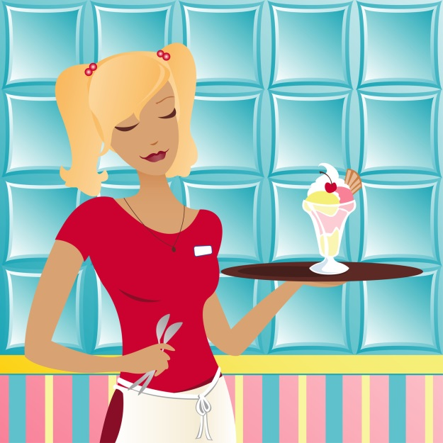The dessert menu, including specialty coffees, desserts, and dessert drinks, are presented at the table and verbally described.

It is a good time to remind guests to save room for dessert, when you return to their table to check on the entrees. At this time, you may want to suggest a few dessert items, to plant the thought. Later, when clearing the table, ask your guests if they are ready to try dessert. You can then begin to describe a few of your favorite dessert items.

In today's health-conscious fat-free society, customers stay away from desserts...NOT TRUE. We will offer some low-fat desserts, but you, the server, can always suggest splitting a dessert and bringing out additional forks or spoons. This is effective salesmanship that will increase your check, and also enhance your guests' experience.

# Wine Service

When ordering a bottle of wine, ring it up as usual on the register. The bartender will give you a chit that you will take to the manager, who, in turn, will issue the bottle.

Present the bottle to the host.

1. 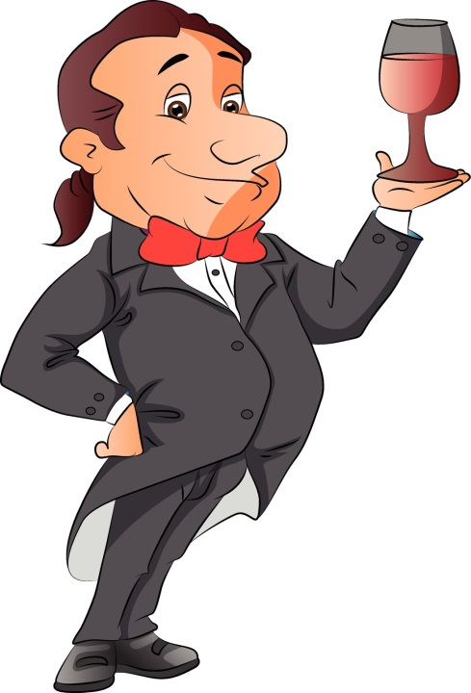Host accepts
2. Host rejects (wrong wine, wrong vintage, changed mind)

Place glassware around the table at the position 4 o'clock from the water glass. Using your Screwpull wine opener cut the capsule and put it in your pocket. Remove the cork and present to the host.

Pour about one ounce for the host to sample.

1. Host accepts
2. Host rejects (based on color, smell, clarity, taste)

If this happens, GET A MANAGER immediately.

Pour wine around the table.

1. About 4 1/2 ounces per glass.
2. Women first, then hostess, then men, then host.
3. Place remainder of bottle in an iced wine cooler.

## VARIATIONS

Red Wine

Bring it and open as soon as possible after the order, so it can breathe.

Do not cool, unless requested.

Second Bottle - Same Wine

Give the host or hostess the option of re-sampling.

Give the host or hostess the option of fresh glassware for everyone.

Second Bottle - Different Wine

Automatically present fresh glassware.

Two Wines simultaneously

Host or hostess gets two glasses.

Host or hostess samples both wines before pouring to the rest of the party.

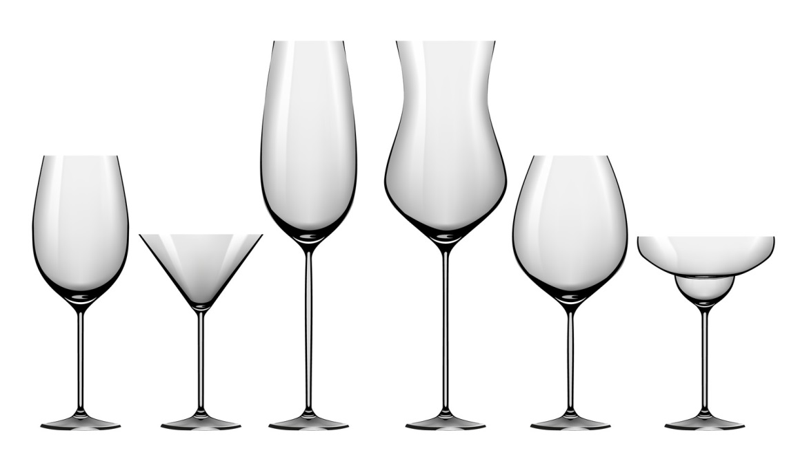All members of party must be given a choice of either.

# Closing Out A Table

## Presenting the Check

Before presenting the check, look it over to make sure you have charged for everything correctly.

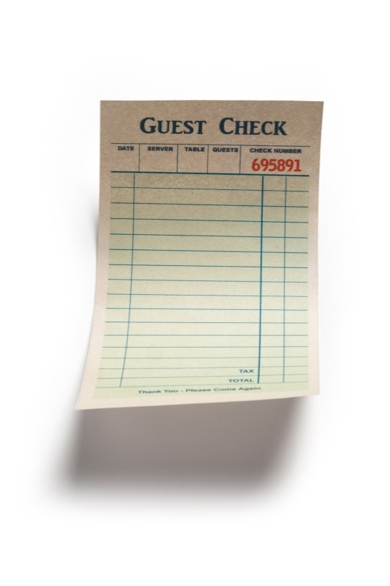Appetizers

Soups

Salads

Entrees

Sides

Desserts

Coffee

Wine

After you have determined that the check is correct, give the check in a booklet to the host of the table (if known), or place it in the center of the table and say "Thank you.” Make sure to let the customer know, at this time, that you are the cashier and will take care of the check whenever they are ready. There is nothing more aggravating for a customer than wandering around looking for a cashier. People also hate to tip when they are standing up by the front door, waiting for the waiter or waitress.

After presenting the check, take a few steps and glance back at the table. If they already have their cash or credit card ready, it may mean they are in a hurry to leave. If this is the case, try to close the transaction immediately or as soon as possible. Guests will notice and appreciate this.

We use a server banking system; you are your own cashier. You are responsible for all your money, including cash, credit card vouchers, comps, discounts and traveler's checks until the end of your shift. You must start your shift with your own thirty-five dollars that is used to make your opening change bank.

If the customer is paying cash, do not make change right at the table!! Take the check and cash to the back of the house, and make change. Return the check and change on either a tip tray, or a book, along with the receipt. If the customer is paying with a credit card, follow the house procedure. Once the guest has signed the voucher, pick up both the check and voucher, and again, thank the customer. DO NOT examine the tip as you leave the dining room!!

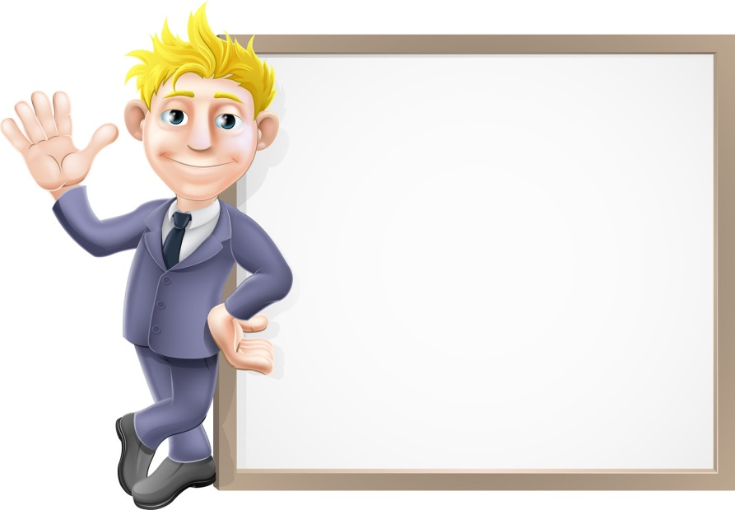REMEMBER, the process of closing out the check is the time when the guest is deciding on the tip amount. A bad impression here can undo all previous good impressions, and have a direct effect on your gratuity.

## The Farewell

When your guests are departing, we have four distinct objectives:

1. To make sure their experience in our restaurant was pleasurable.
2. Thank them, by name, for their patronage.
3. To invite them back for another visit soon.
4. To make sure their last impression is a positive one.

# Methods of Payment

Approved methods of payment are cash, VISA, Master Card, and American Express, and checks. All other methods of payment, i.e. Travelers Cheques, require management approval. When accepting personal checks, you must get approval by management, and include the following information:

Driver's license number

Current address

Phone number (day and evening)

## Handling Cash

Here are the procedures to follow when receiving a payment in cash -

1. 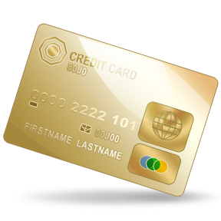As noted above, never make change at the table - go to the nearest server station.
2. When making change, always count it twice.
3. Give the guest some one’s and five dollar bills to tip you with.
4. Return the change to the guest's table on a tip tray.
5. Always keep your cash and receipts in a wallet or your apron.
6. Paper bills make no noise when it hits the floor so be very careful with your bills.
7. Never leave your money or wallet unattended.
8. If you are concerned about carrying too much cash during a shift, make a drop with a manager in exchange for an IOU.
9. Always remember, treat credit card vouchers like they are cash - THEY ARE. Handle with care!

# Check-Out Procedures

1. Your computerized register system will print out your guest check at the end of each table's meal. This alleviates the issuance of any manual guest checks.
2. Once a guest check is printed out and a customer has paid, you will close out that check to cash, Master Card, VISA, or American Express, or other forms of payment. You must keep all printed out closed guest checks for checkout.
3. Before beginning your checkout each shift, check the following:

Make sure all your customers are through, have been tabbed, and do not need anything else. I.e., coffee, tea, etc.

Be certain the manager has closed your section for the shift.

Make sure you have collected from all of your tables and have all your tickets with you.

Make sure all plates, silverware, glassware, and containers are cleared from all of your tables.

Be certain that all of your side work and closing duties are done.

Make sure that you have your full uniform on at all times, while in the front of the house.

Have a manger do any deletions of voids, over rings, and promo tickets. All over rings must be signed by a manager at the time they occur, and not at the end of the shift. You never sit down to eat, drink, or smoke until all of the above are completed. Starting your checkout before all your customers are finished is grounds for termination.

## Over Rings Or Voids

Any time you make a register mistake of an item you did not want to ring up. Get a manager immediately to correct this on the register, and notify the kitchen or bar NOT TO PREPARE THAT ITEM. Over rings and voids are register mistakes of items never served or prepared.

## House Promo

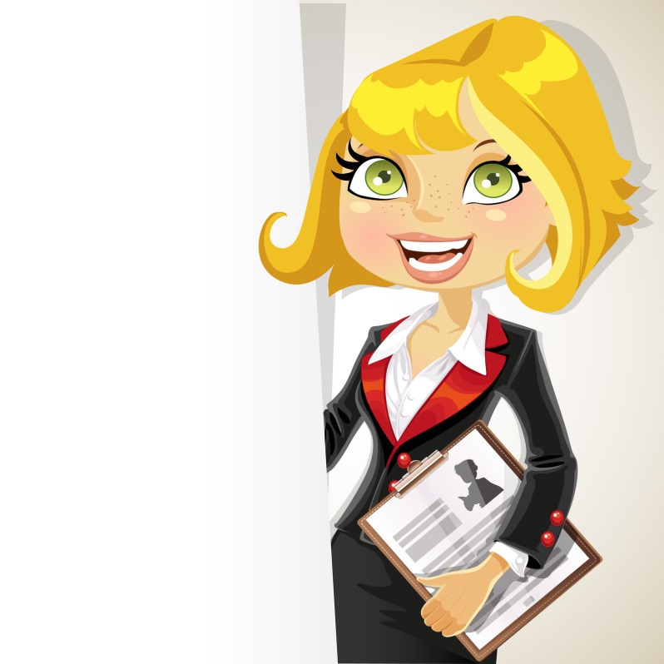Occurs anytime an item has been prepared and served to a customer that was not satisfied with the item. Perhaps it was under or over cooked, or the glass was chipped, etc. This would include a customer waiting too long for their meal. Only a manager can do this function on the register. Get the manager before closing any house promo tickets.

## Manager Promo

Occurs anytime a manager wishes to buy a table a round of drinks, perhaps a dessert, or any free purchase approved by a manager promoting good will to our patrons. Inform the manager when you are serving a regular guest you would like to buy a drink for, a special guest to send an appetizer out to, a large party, or to send complimentary desserts. Please introduce the manager to these customers by name. We want to help you develop a large regular following. From time to time, the restaurant will have contests promoting such clientele builders. Get the manager on duty before closing out any manager promo tickets.

## Employee Discount/Customer Discount

Occurs anytime the full amount of an item will not be collected. For example, employee meals or coupons offering $2.00 off any menu item, or buy one, get one free coupons, or frequent lunch program discounts. Only a manager can discount guest checks on the register. Get the manager on duty before closing out any discount checks.

## Now You Are Ready To Check Out!!

1. Arrange your tickets, top to bottom, in the following order:

All promo tickets - manager, house discounts and other charges.

All charges, separated in this order: 1) American Express, 2) Master Card, and 3) VISA. Be certain merchant copy of the charge voucher is stapled to the paper guest check.

All remaining cash tickets.

1. Prepare the Server Checkout Sheet. Make sure you have no open checks.
2. Be certain charge totals of Master Card, VISA, and American Express, along with promos, discounts or other charges balance with what you have on your guest checks. Use the calculator to double check. If they do not balance, this means that you are missing a guest check, or charge receipt

NOTE: Add only items that were actually rung up on the register. If you bought a customer’s cigarettes, for example, and you added that money in on their tab by hand, do not include it in your actual totals. This will prevent you from balancing to the register.

1. The following items should be ready for the manager, before you enter the office:

Promo checks, houses, and over rings accounted for on register.

Have all money counted and faced.

Have all charge vouchers matched with the ticket they paid for.

All tickets in order, with houses, promos, then charges, and cash tickets as previously stated. There should only be ONE person in the office doing checkout at a time. This helps eliminate unnecessary confusion and mistakes. Please use the calculator provided for you.

Have the Check Out Sheet completed up to the register reading entries.

1. The manager will give you your register reading to enter on your Check-Out Sheet. The register reading will include your total sales and your total cash due. Cash due = total sales - charges. Count out cash due and have ready in the largest denominations of bills possible.

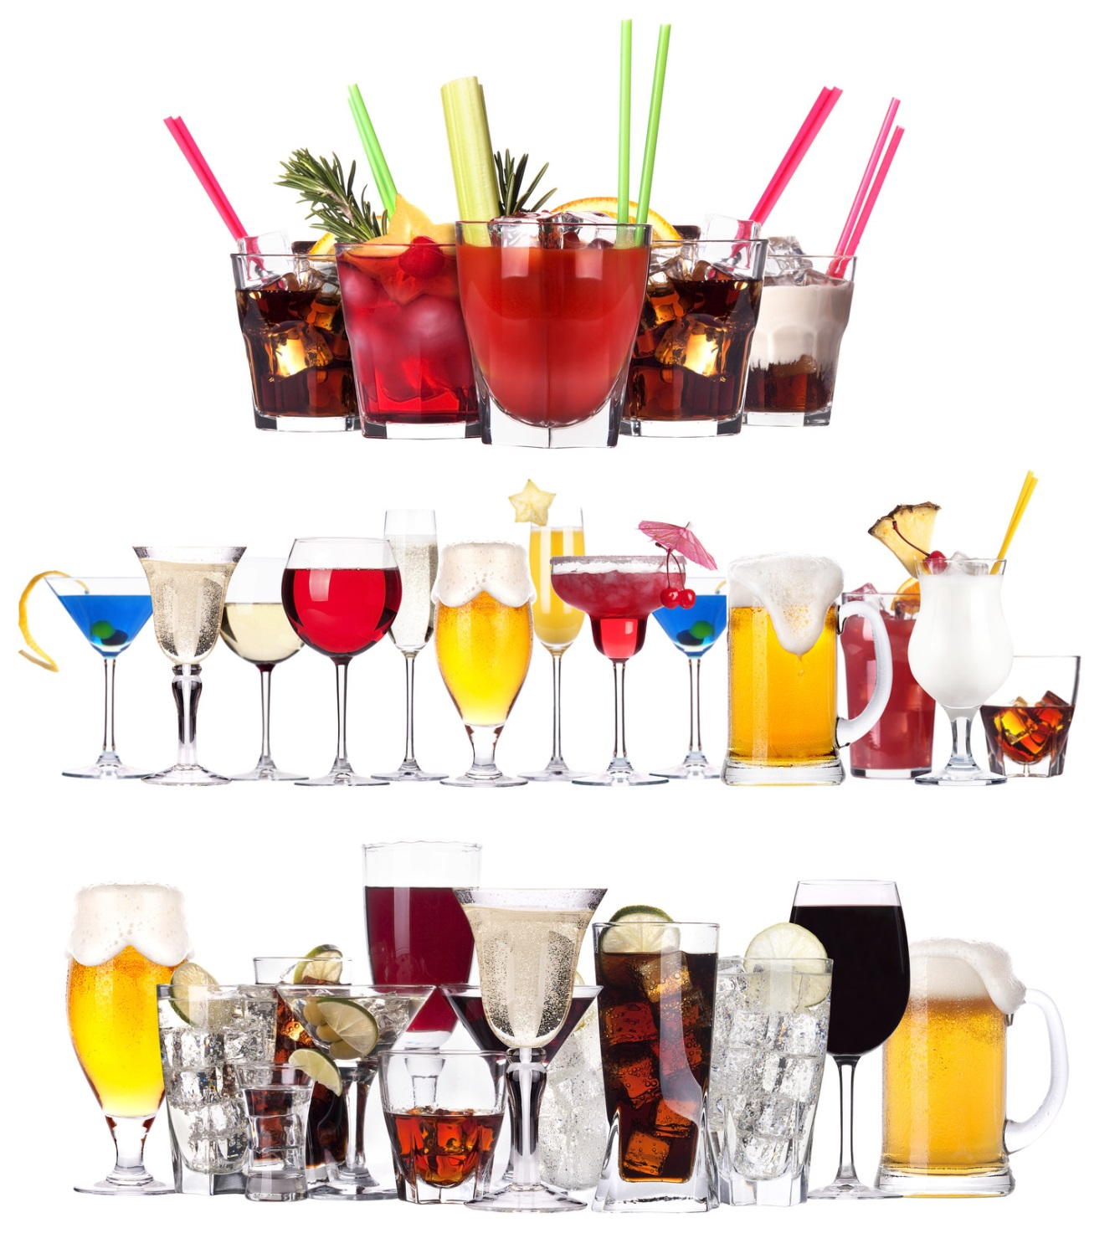If for some reason you cannot balance to the register totals, ask the manager for assistance.

# Alcohol Awareness

Alcohol Awareness is a growing concern within the Hospitality Industry nationwide. By recognizing the "early" signs of intoxication, monitoring your customer's consumption, and treating them as you would a guest in your own home; you fulfill your responsibility and protect the guest.

## To serve or not to serve?

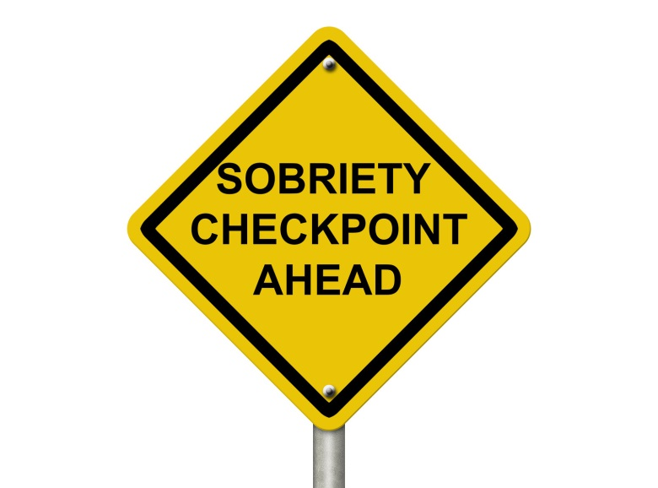By understanding and fulfilling your responsibilities...

### Your Role:

Observe

Monitor

Report

Assisted by the guidance and support of management...

### Your Manager's Role:

Confirm

Confront

Resolve

### With Adherence To The Company's Policies...

We will not knowingly admit obviously intoxicated for underage customers to the bar.

We will not knowingly serve alcohol to an obviously intoxicated or underage customer.

We will offer alternatives to alcohol.

We will create an atmosphere to promote responsible drinking.

We will make a reasonable attempt to prevent obviously intoxicated customers from driving.

### . . . We Can Accurately And Confidently Answer That Very Important Question.

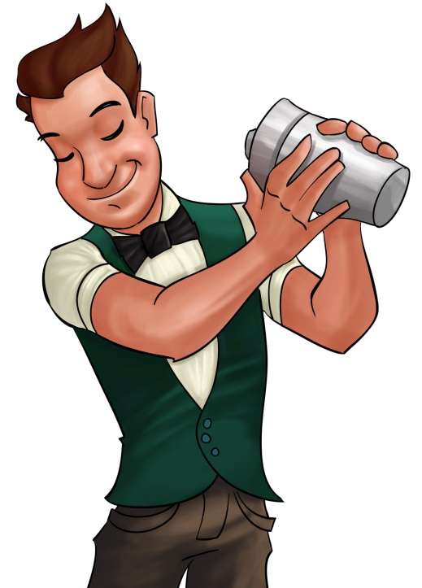Responsible service of alcohol requires a team effort.

Know and watch for the signs of intoxication. If there is any question, avoid further service and report to a manager who will make the final decision and determine whether the guest should remain or leave.

If you know what it takes to get someone drunk, you can prevent it by monitoring their consumption and offering alternatives.

Do not allow drunks to come in, and do not allow intoxicated guests to drive.

Hospitality is our business. Beverage service is only one element.

Cooperation between employees and management allows us to exercise a degree of influence on the behavior of our customers that will result in an atmosphere of responsible drinking.

This is just a portion of our company Alcohol Awareness program. A complete handbook with certification test is provided at orientation.

# Sanitation

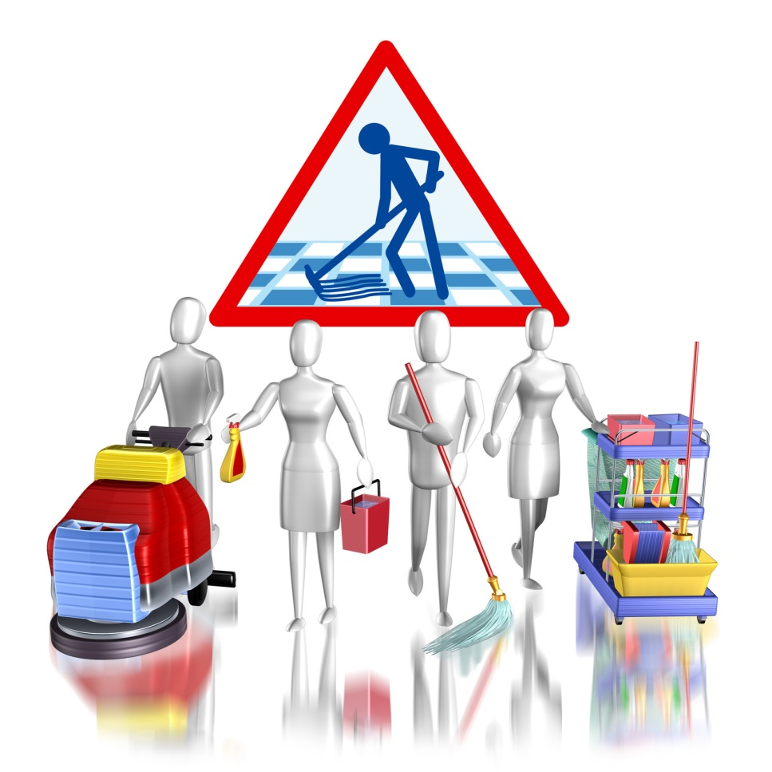The responsibility of management and staff to protect the public from food borne illness is fundamental. A food borne illness is simply a disease that is carried, or transmitted, to human beings by food. Throughout your training, you will receive information concerning proper temperatures of food storage and serving, as well as, cleanliness standards, proper use of chemical cleaning, and disinfectant products. It is our objective to operate the restaurant at the highest level of cleanliness and sanitation for the benefit of our customers and employees.

# Safety

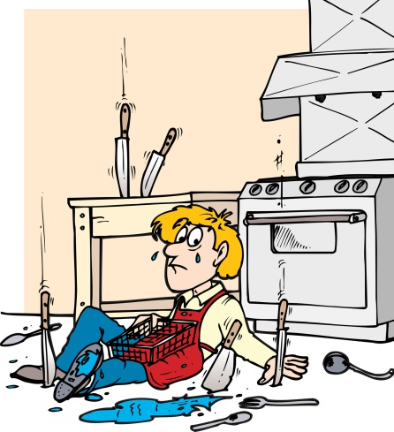In addition to a clean and sanitary environment, [Restaurant Name] provides a safe environment. One of our goals here at [Restaurant Name] is to operate an accident-free restaurant. A safe restaurant takes teamwork and effort on everyone's part. Everyone who works with cleaning chemicals will receive training on the use of those products, and will be tested following the guidelines of OSHA Hazard Communication Standard, Title 29 Code of Federal regulations 1910.1200.

Safety meetings will also be used to review information presented from the initial training, and a safety representative will be selected for the Employee Associate Board of Directors. Management's role is to provide the daily monitoring of safe work practice developed from these meetings.

Whenever you see a potential hazard, or something you notice as unsafe, notify a manager immediately.

Here is a list of guidelines to follow for safety and sanitation:

## Major cause of food borne illness

Food left in the danger zone of 40° to 140° for four or more hours. Keep all foods out of the danger zone of 40° to 140°.

Keep hot foods hot, and cold foods cold.

Handle foods quickly during delivery, and put refrigerated and frozen foods away as soon as possible.

Sloppy personal hygiene habits will not be tolerated.

Do not prepare food a day or more before serving.

Do not serve food that is not completely cooked.

Thaw foods in refrigerator, microwave, or under cold running water for not more than 2 hours, followed immediately by cooking.

Avoid preparing food in advance, unless absolutely necessary.

Inspect Foods thoroughly for freshness and wholesomeness upon receipt, cooking, and serving.

Only use sanitized equipment and table surfaces.

## Always wash your hands after you

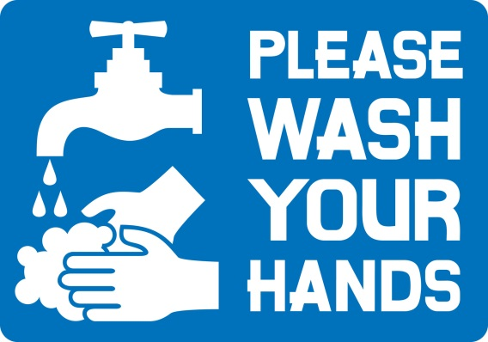Smoke, eat, use the restroom; touch money, raw foods, or your face, hair or skin; cough, sneeze, or blow your nose

Comb your hair, handle anything dirty

Before and after taking a break

## Dispose of waste properly

Take garbage out frequently.

Keep garbage areas clean and sealed.

Clean and sanitize garbage cans regularly.

Store soiled linen in a laundry bag or non-absorbing container.

## Keep insects and animals out by

Keeping doors closed.

Taking garbage out frequently and keeping garbage areas clean.

Report any holes where an animal can enter.

Do not provide a free meal for any animals.

## Handle ice and tableware properly

Use clean scoops or tongs to pick up ice, do not use hands or glass.

Store scoops or tongs in a clean container, not in the ice.

Do not store any food or beverage in the ice.

Avoid touching food contact surface with dishes, utensils, etc.

## Avoid cross contamination from one food item to another

Keep separate cutting boards for raw and cooked foods.

Never mix leftovers with fresh food.

Store fresh raw meats, poultry, and fish on lowest racks.

Sanitize thermometers after each use.

When thawing raw foods in the refrigerator, place them on the lowest shelf.

## Store foods and equipment properly

Cover, label, and date foods in storage.

Do not store food in open cans.

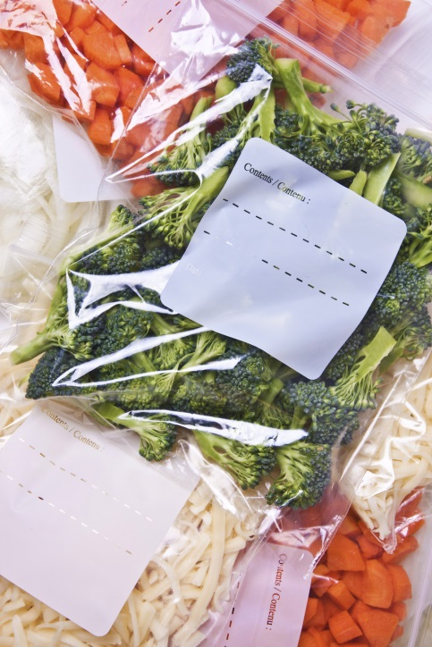Store new foods behind old ones.

Store food off the floor and away from the wall.

Check temperatures of refrigerators and freezers daily.

Defrost freezers as necessary. Frost build up causes freezers to warm up.

Dry goods and storage areas should be cool and dry for good storage.

Do not store food or equipment under exposed server lines.

Keep storage areas clean.

Store all equipment so that dust cannot settle on it.

Store chemicals and pesticides separately from food.

## When cleaning stationary equipment

Unplug equipment, and make sure hands are dry.

Disassemble.

Wash removable parts in dish machine, or three-compartment sink.

Wash and rinse stationary parts.

Sanitize food contact surfaces with sanitizer.

Air dry before reassembling, without touching food contact surfaces.

## Preventing falls

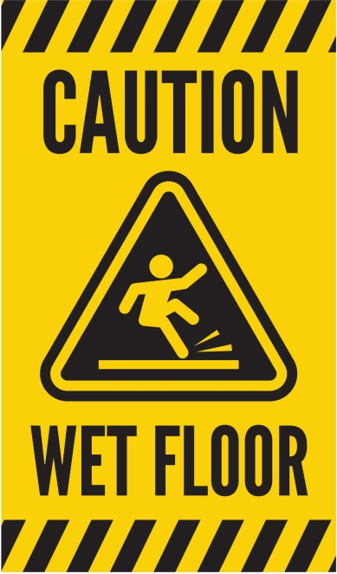Wipe up spills immediately.

Use "wet floor" signs.

Wear shoes with non-skid soles and heels.

Keep isles and stairs clear.

Walk, and do not run.

Follow established traffic patterns.

Do not carry anything that blocks your vision.

Keep drawers closed.

Use ladders properly; never use chairs, tables or boxes. Do not stand on top of ladder, and do not over reach.

Use handrails on stairs.

Turn lights on to see.

Never run in the kitchen. The floor may be wet.

Never leave anything on the floor including ice from the ice machine.

## Preventing electric shock

Never touch electrical equipment with wet hands, or while standing in water.

Unplug equipment before cleaning or disassembling, to avoid shock.

Do not yank plugs out by cord. This can cause damage to the cords, which may then cause shocks.

Report damaged and worn plugs and cords to your supervisor.

## Lift Properly

Plan it. Do you need help? Could you use a cart? Where is it going? Which route is best?

Get ready. Spread feet apart, shoulder width. Put one food slightly in front of the other for a good support base. Squat down with back straight and head up. Do not bend over from the waist! Grip the object firmly with both hands. Keep elbows and arms close to body. Tuck in chin. If lifting a tray, squat down alongside the tray and slide the tray onto your shoulder and hand.

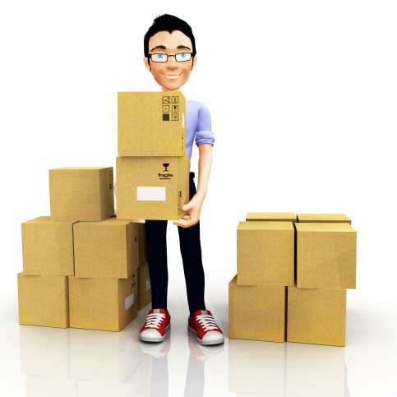Lift it! Straighten your knees slowly and smoothly to a stand. Avoid doing this in a quick or jerky manner. Do not lift and twist at the same time.

Move it! Keep object close to you. To change position, move your feet and entire body. Do not twist from the waist. Look where you are going and call out "coming through" as needed.

Set it down! Bend your knees slowly and smoothly. Slide load into place; watch your fingers and toes.

## Moving a cart properly

Push rather than pull.

Spread feet wide, one in front of the other with your front knee bent.

Keep back straight.

Slowly push into the cart with your body weight, using your leg muscles to do much of the pushing.

Push slowly and smoothly. Avoid sudden motions or twisting your back.

## Preventing Cuts

Know how to operate equipment.

Pay attention when using sharp equipment. Never touch edges of sharp blades.

C:\Users\Karens Laptop\AppData\Local\Microsoft\Windows\Temporary Internet Files\Content.IE5\D5JUHB1P\MC900030340[1].wmfUse guards when provided on equipment.

Use tampers to push food into equipment.

Turn equipment off before adjusting.

No loose sleeves, ties, or dangling jewelry should be by equipment

Use knives carefully.

Carry dishes and glassware carefully.

Sweep up broken glass; do not use your hands.

Use special container to dispose of broken glass, dishes, and other sharp objects.

Remove can lids entirely from cans, then dispose of them.

## Preventing burns

Pay attention when working around hot equipment.

Use dry potholders or towels when handling hot equipment. Wet or moist towels will serve as conductors of heat.

Keep pot handles turned in from the edge of the range and open flames.

Avoid overfilling containers with hot foods.

Get help lifting heavy pots of hot foods.

Open lids of pots and doors of streamers away from you, and do so slowly, to avoid a steam burn.

Stir foods with long-handled spoons.

Warn others of hot surfaces.

Let equipment cool before cleaning, and do not use wet rags.

Do not put icy frozen foods into the fryer. Put foods slowly into the fryer and stand back to avoid being splattered.

Strike match before turning on gas equipment, to avoid a flare-up.

Wear closed-toe and closed-heel shoes that do not absorb liquids.

Warn guest of hot dishes.

## Preventing fires

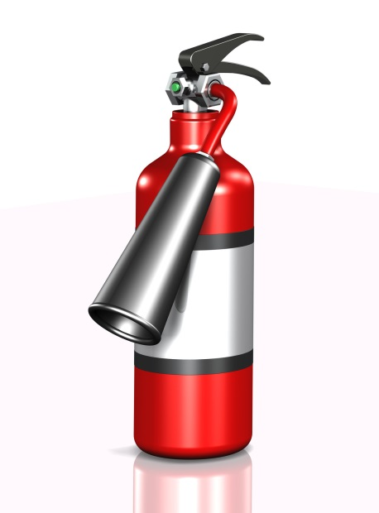Smoke only where allowed.

Do not turn your back on hot fat, as it may burst into flames.

Keep equipment and hoops from grease build up because grease causes many food service fires.

Do not set the fryer at too high a temperature.

Store matches in a covered container, away from heat.

Keep garbage in covered container, away from heat.

Store chemicals away from heat because many chemicals are flammable.

## Safe chemical handling

Do know where the material safety data sheets are posted, and read them.

Do read the labels of all products, before you use them.

Do follow the directions for proper storage, handling, and use for all chemicals you use.

Do ask your supervisor any questions or concerns you may have about using a certain products.

Do know how to call for medical help, in case of an emergency.

Do not ever mix chemicals together.

Do not store chemicals in unmarked containers.

Do not store chemicals in or close to food storage, preparation, or serving areas.

Do not leave aerosol spray containers near heat or spray close to an open flame.

Do not dispose of any empty chemical container until you have checked on the label for how to do so.

## Reading the MSDS (Material Safety Data Sheets)

Read product name.

Fire hazard - explains if the product can catch fire or explode.

Health hazards - explains effects of over exposure and first aid procedures.

Spill precautions - explains steps to take in case of spills.

Special protection - describes any special measures, such as goggles and rubber gloves, used to decrease exposure and risk.

# Conclusion

There is a lot of information contained in this manual! Believe it or not, however, there is even more information that is not.

We have given you the basics, as we view them, and how we would like them to be conducted. There is no section in this manual concerning "Teamwork." The reason for this is that we feel this topic falls under the "Common Sense" category. We expect the host staff at [Restaurant Name] to possess this common sense from the word "GO."

We want you to use the service tips in the manual, along with your common sense, and above all, YOUR individuality, to help create an atmosphere that will encourage good times for our customers, and yourself. If this happens, you will be ensuring the success of not only [Restaurant Name], but also yourself.

GOOD LUCK!!!

